`ASSIGNMENT 7

NAME:Thirumalasri .P

REG. NO.:240701569

INITIAL WEBSITE:

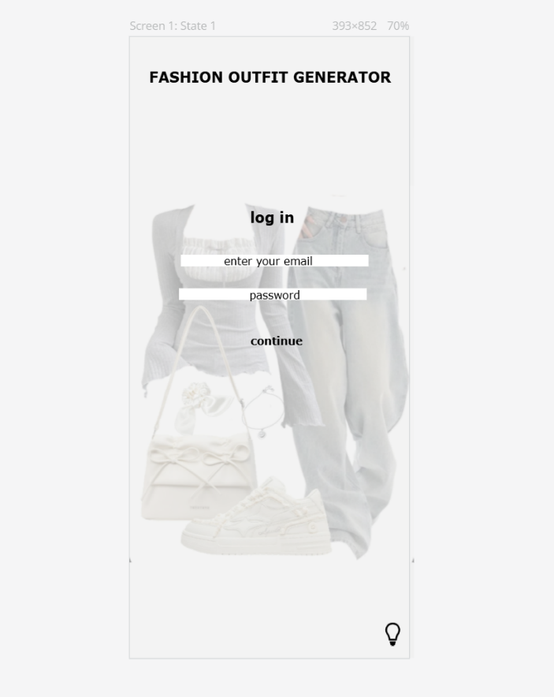
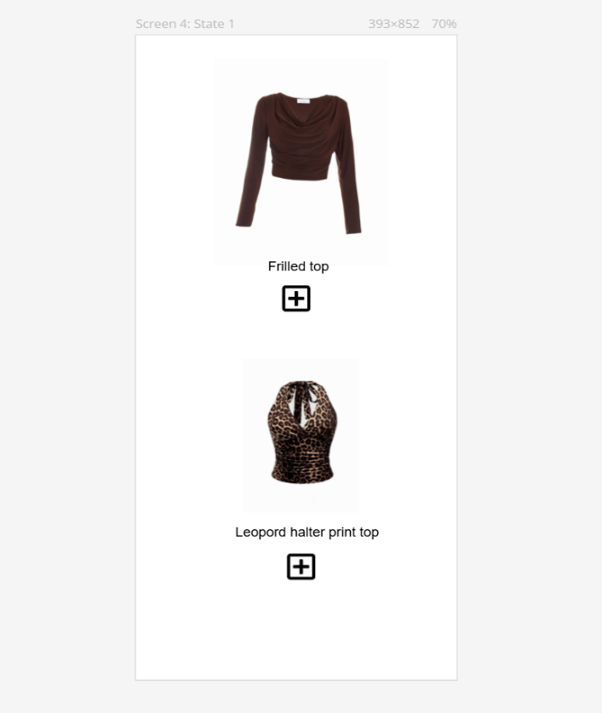
FEEDBACK FORM:

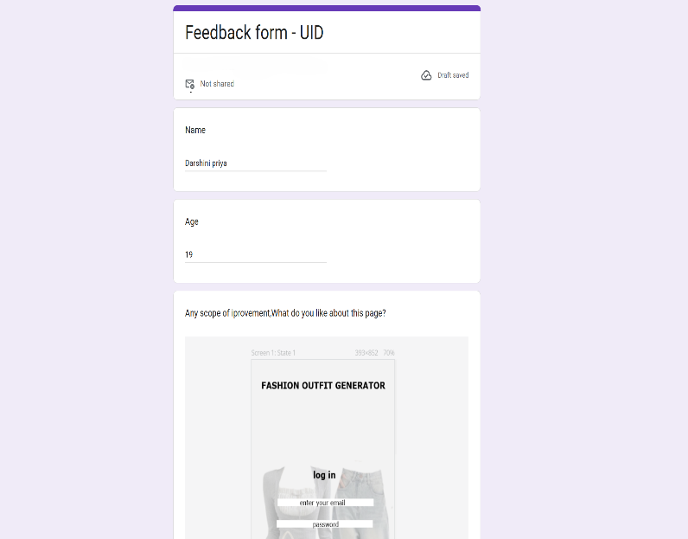

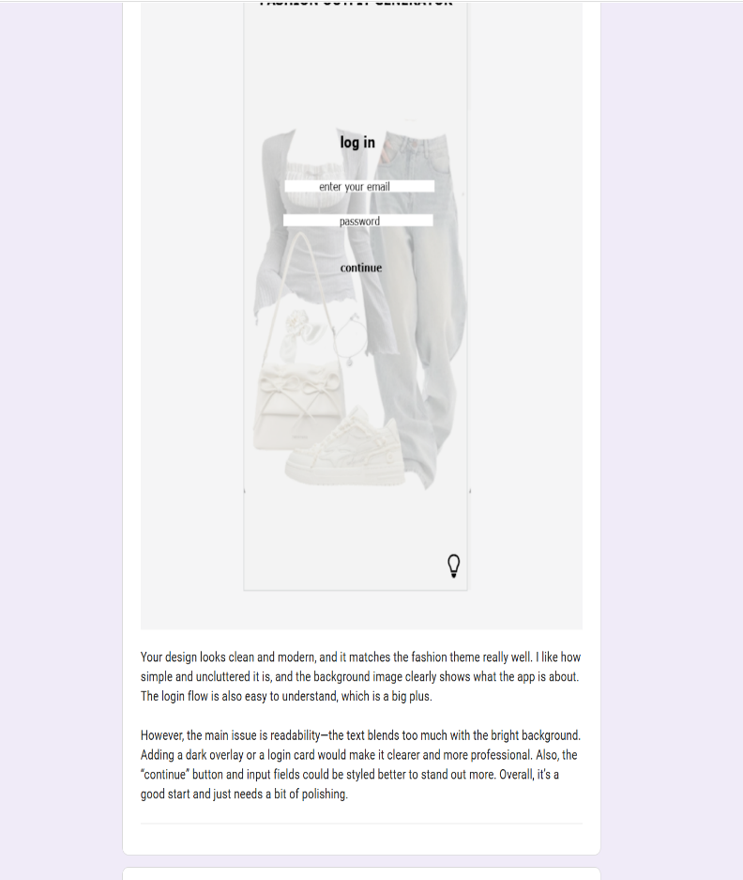
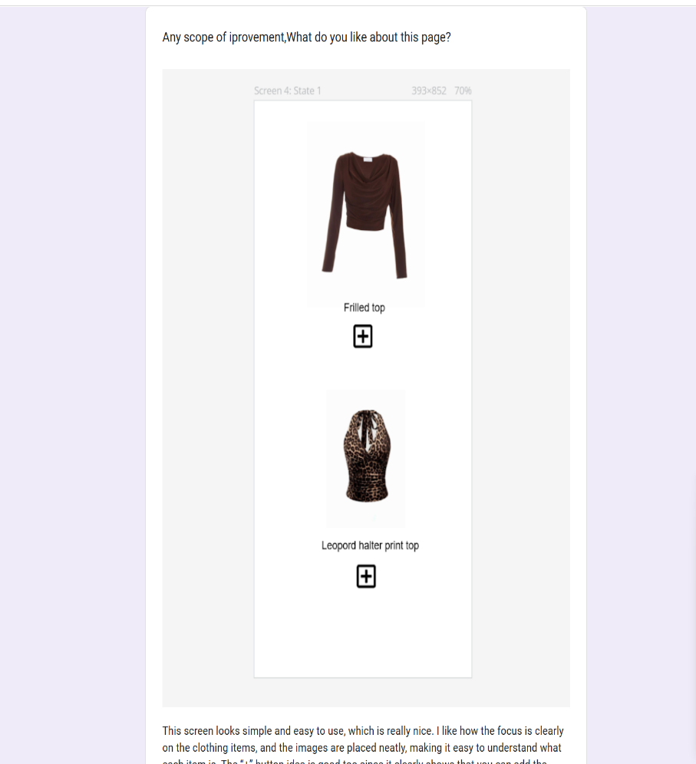

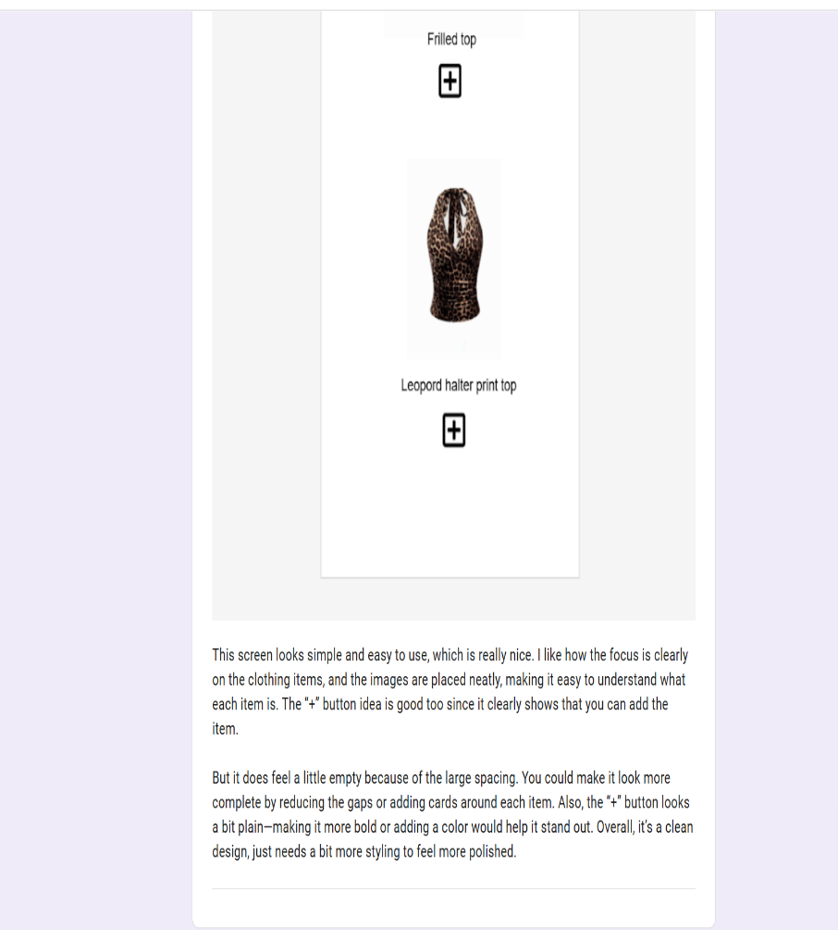
With reference to your image, a feedback form is a page where users enter their details (like name and age) and share their opinions about a design—in this case, your fashion app screens.
In your form, users are shown the app interface and asked what they like and what can be improved. This helps collect useful suggestions, identify issues (like readability or spacing), and improve the overall design. Feedback forms are commonly used to gather user opinions and improve products or experiences based on real input.
A feedback form is used to collect users’ opinions and suggestions about a design or product. In this case, it helps understand what users like about the fashion app screens and what improvements can be made to enhance the user experience.

CUSTOMER OPINION:
Overall, your design has a clean, modern feel and fits the fashion theme really well. The layouts are simple and easy to understand, and the use of relevant images makes the purpose of the app clear. The minimal approach works in your favor because it doesn’t overwhelm the user and keeps the experience smooth.
However, both screens need a bit more polish. The main issue is readability and visual strength—text and elements don’t stand out enough, especially on the login screen with the bright background. Adding a dark overlay or using cards would improve clarity. Buttons like “continue” and the “+” icons also need stronger styling so they look more interactive. The spacing in some areas feels too large, making parts of the design look slightly empty.
In short, it’s a strong and well-thought-out concept with good structure, but improving contrast, button design, and spacing will make it look more professional and complete.

ALTERED WEBSITE:
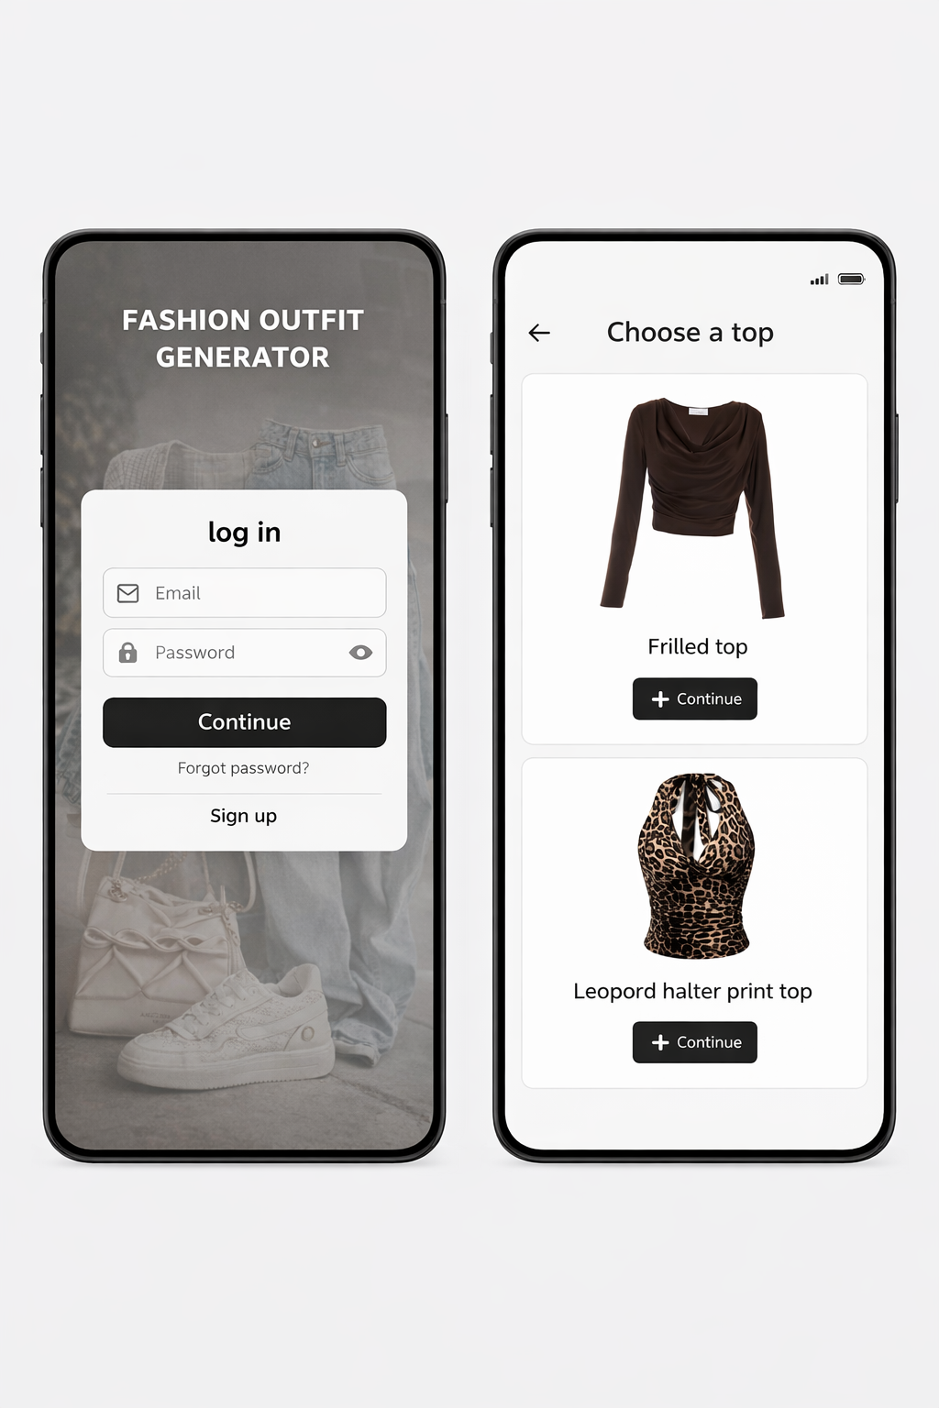
This design presents a clean and modern interface for a fashion outfit generator app. The login screen uses a blurred background with a clear card layout, making the form easy to read and interact with. The second screen neatly displays clothing options in styled cards with clear images and action buttons, making it simple for users to browse and select items. Overall, the design feels minimal, user-friendly, and visually aligned with a fashion-focused application.

PROTOTYPE LINK:
https://pr.to/1DG88Y/
https://pr.to/1DG88Y/
https://docs.google.com/forms/d/e/1FAIpQLSeeuTRIs4nJEdR5-8pxfbd757TWIBBDTHX0p1bEvO9FHgcxSA/viewform

